

------------------------------------------------------------------------------------------------------------------------------------------**Press Release 21 February, 2019**

------------------------------------------------------------------------------------------------------------------------------------------

**MSE sentiment ticks up: CriSidEx**

Both manufacturing and services units see momentum increasing this quarter

**Mumbai/New Delhi:** Sentiment among Micro and Small Enterprises (MSEs) improved in the quarter ended December 2018, the latest CriSidEx score shows. CriSidEx or the CRISIL-SIDBI MSE Sentiment Index was launched by CRISIL Ltd. and Small Industries Development Bank of India (SIDBI) last year.

At 128, the score was higher than 124 for the preceding quarter and also a significant improvement over 107 for the corresponding quarter a year ago.

The change was driven by an increase in order book size and employee base for manufacturing MSEs and an increase in profit after tax margin and employee base for services MSEs.

To be sure, the December quarter had its share of favourable macroeconomic factors such as festive season, rupee depreciation, and a decline in oil prices, though it also bore the impact of headwinds such as the NBFC liquidity crunch, which shows in the 5th CriSidEx readings.

Among service providers, 41% reported a good survey quarter, indicating improvement over all previous surveys. Among manufacturers, 42% reported a good quarter – an improvement over the quarter immediately preceding it.

By and large, the respondents expected the feel good to hold in the next quarter, too.

Shri Mohammad Mustafa, IAS, Chairman & Managing Director, SIDBI said, “For January-March, both manufacturing and services companies were optimistic of a good business performance. Over 50% of the respondents each from manufacturing and services expected the positive momentum to continue. In the manufacturing space, pharmaceuticals, gems & jewellery, and chemicals, and in services, professional services, traders, logistics & power, and power utilities were the most optimistic.”

Among other trends, smaller MSEs had a better outing in the survey quarter – at 49% of those with less than 10 employees compared with 44% of those with more than 25 employees.

Classifying by legal constitution, companies were more optimistic, with 44% reporting a good quarter, compared with 40% of firms.

In terms of order book, 41% of the MSEs reported an increase, higher than 40% in July-September 2018 and 27% in October-December 2017.

Export-oriented MSEs fared better than their domestic peers, with 48% reporting an increase in order book as against 41% of domestic peers. For the first time in the five surveys so far, exporters reporting a good quarter surpassed domestic market-focused units – marking a trend reversal.

Among importers, the share of respondents who increased their orders in October-December spurted to 25%, from 14% the previous quarter – the highest any survey so far.

In term of volume of production, as much as 57% of manufacturing MSEs expected an increase in production in the January-March quarter and only 6% expected it to be lower. Capacity utilisation was expected to broadly mirror the production trends.

Employment improved, with 20% of the MSEs reporting additions to their employee base in October-December compared with 14% in July-September. What’s more, 26% expected to add employees in the January-March quarter, while only 6% intended to reduce headcount.

At the other end, lenders expected a minor improvement in asset quality.

Shri Amish Mehta, Chief Operating Officer, CRISIL Ltd. said, “Three out of 10 lenders surveyed saw an improvement in the overall business situation of MSEs and 5 out of 10 rated it as satisfactory. These lenders expected the business situation to remain unchanged in January-March – with 3 out of 10 having a positive outlook on MSEs.”

That said, the lenders expected the weakness in MSE asset quality to marginally reduce, with 5 out of 10 believing Non-Performing Assets (NPAs) in the segment will not change, 4 in 10 believing it will decrease, and only 1 in 10 believing it will increase.

**About SIDBI:** Since its formation in 1990, SIDBI has been impacting the lives of citizens across various strata of the society through its integrated, innovative and inclusive approach. Be it traditional domestic industry, small units, bottom-of-the-pyramid entrepreneurs, medium enterprises to high-end knowledge-based industries and export promotions, SIDBI has directly or indirectly touched the lives of more than 360 lakh people in the MSEs sector, through various credit and developmental measures.

For more information, please visit: <https://www.sidbi.in/>

**Media contact:** Neelasri Barman, Mobile: +91 8879760249, E-mail: neelasrib@sidbi.in

**Annexure**

CriSidEx score indicates an upbeat MSE sector

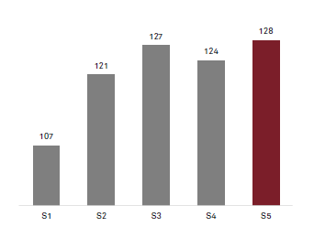

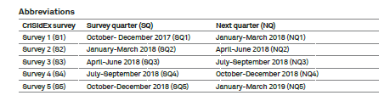

|  |
| --- |
| **Manufacturing** |
|  |
| **Services** |
|  |

Services doing better in east, manufacturing in north

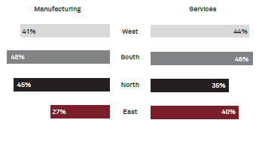

Larger MSEs more positive in manufacturing, smaller ones in services

