**Place: Lucknow तारीख/Date:--30.05.2018**

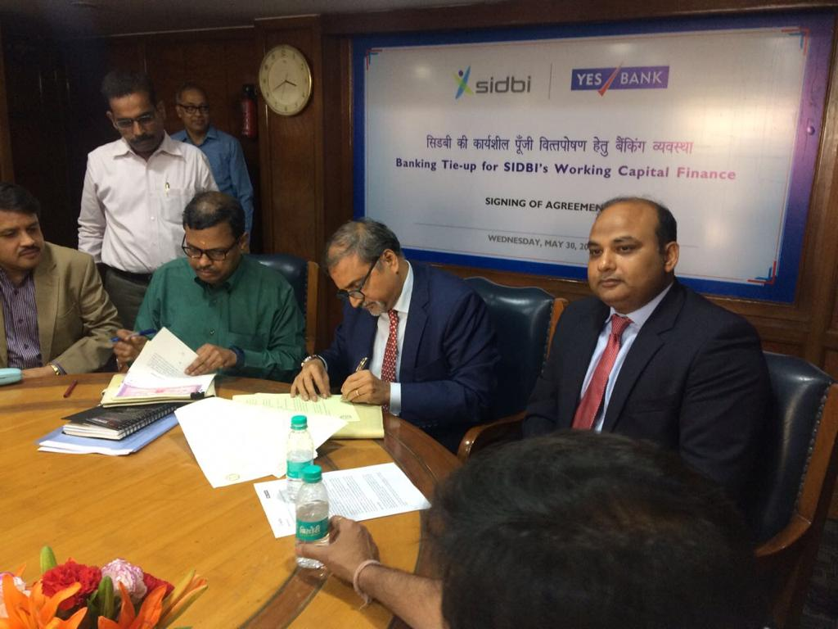

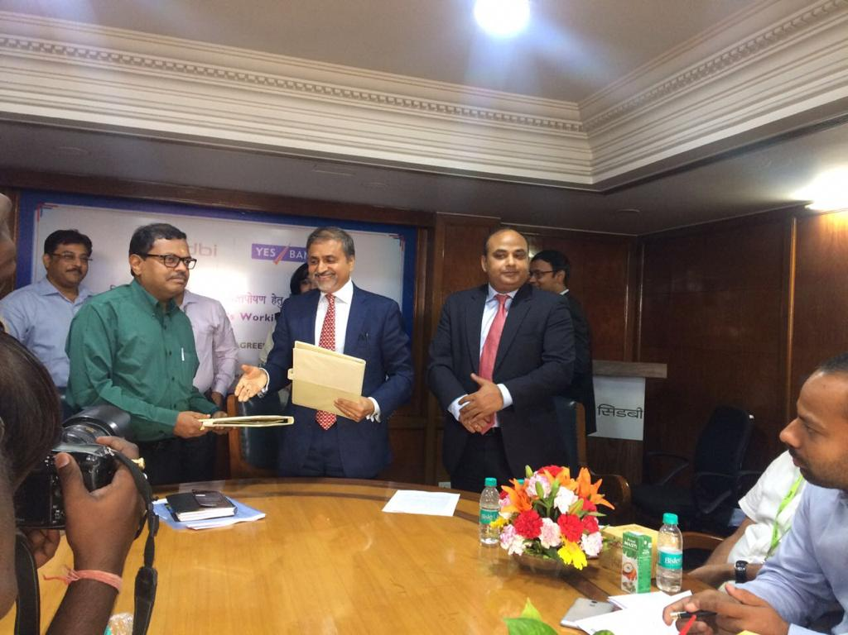

**Press Release**

**Lucknow, May 30, 2018:** YES BANK signed an MoU with Small Industries Development Bank of India (SIDBI) to become the preferred financial institution to extend banking facilities to SIDBI’s customer. The MoU will facilitate smooth flow of credit in a hassle-free manner to SIDBI’s MSME customers availing Term Loan facility from SIDBI. The MoU is a formal agreement between SIDBI and YES BANK to channelize various banking solutions to MSMEs. SIDBI is currently offering Term Loans to MSMEs at an interest rate of 8.12% p.a. Under this MoU, these MSMEs will avail working capital finance from SIDBI which will be channelized using Yes Bank platform. These customers of SIDBI will also be entitled to use YES BANK’s varied banking solutions which include – digital banking products through various channels, current accounts, Cash Management Services (CMS), amongst several others.

**Shri Mohammad Mustafa, IAS, Chairman and Managing Director, SIDBI said:**

In line with its invigorating vision of SIDBI 2.0, SIDBI has been taking all such steps which can instil vibrancy in MSME eco-system and partnership with Yes Bank is an endeavour along these lines to ensure that finance reaches the doorsteps of MSMEs on the back of robust technology and efficient service delivery.

About YES BANK

YES BANK, India’s fourth largest private sector Bank with a pan India presence across all 29 states and 7 Union Territories of India, headquartered in the Lower Parel Innovation District (LPID) of Mumbai, is the outcome of the professional & entrepreneurial commitment of its Founder Rana Kapoor and its Top Management team, to establish a high quality, customer centric, service driven, private Indian Bank catering to the future businesses of India.

YES BANK has adopted international best practices, the highest standards of service quality and operational excellence, and offers comprehensive banking and financial solutions to all its valued customers.

YES BANK has a knowledge driven approach to banking, and offers a superior customer experience for its retail, corporate and emerging corporate banking clients. YES BANK is steadily evolving as the Professionals’ Bank of India with the long term mission of “BUILDING INDIA’s FINEST QUALITY LARGE BANK”.

**About SIDBI:**

Small Industries Development Bank of India (SIDBI), is the Principal Financial Institution for the Promotion, Financing and Development of the Micro, Small and Medium Enterprise (MSME) sector and for Co-ordination of the functions of the institutions engaged in similar activities.

The business domain of SIDBI consists of Micro, Small and Medium Enterprises (MSMEs), which contribute significantly to the national economy in terms of production, employment and exports.

SIDBI meets the financial and developmental needs of the MSME sector with a Credit+ approach to make it strong, vibrant and globally competitive. Presently, SIDBI has embarked upon a mission to exploit the existing banking/ non-banking financial network to reach out to MSMEs through strong sustainable partnerships. SIDBI has also taken pioneering initiatives in strong data driven flagship programmes with other agencies like CRISIDEX, MSME pulse, etc. which we will go a long way in addressing the issue of information asymmetry in MSME ecosystem.