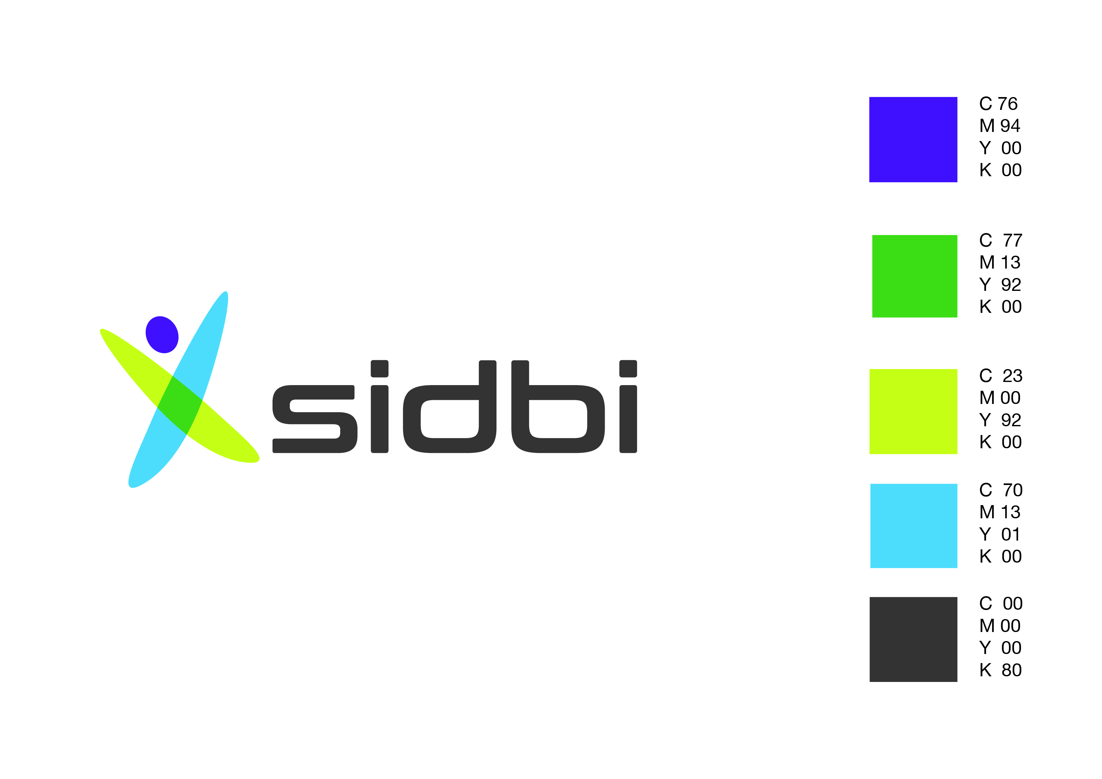
SMALL INDUSTRIES DEVELOPMENT BANK OF INDIA
First Floor, Kamda House, Next to Hotel Shraddha,
Savedi, Nagar Manmad Road,
Ahmednagar-414003, Tel:(0241)2426066
Website www.sidbi.in

E-Auction Sale Notice for Sale of Movable and Immovable Assets under the Securitisation and Reconstruction of Financial Assets and Enforcement of Security Interest Act, 2002 read with proviso to Rule 6(2) and Rule 8(6)] of the Security Interest (Enforcement) Rules, 2002

Name and Address of the Secured Creditor | Small Industries Development Bank of India  First Floor, Kamda House, Next to Hotel Shraddha, Savedi, Nagar Manmad Road,  Ahmednagar-414003, Tel:(0241)2426066
Name and Address of the Borrower/Mortgagor | Borrower  Ujwal Electrical Stampings Pvt. Ltd.  L-31, MIDC, Nagapur, Ahmednagar-414111, Maharashtra.  Mortgagor – Shri Anil Ragho Sali  - Ujwanil Bunglow, Bank of Baroda Colony, Balikrishna Road, Savedi Ahmednagar-414003(Maharashtra)  - RM 30, MIDC, Nagapur, Ahmednagar- 414111, Maharashtra.
Name of the Guarantors | Shri Anil Ragho Sali and Smt. Ujwala Anil Sali
Date of NPA, Date of demand notice and total dues as per Demand notice | Date of NPA: 11/05/2017,  Date of demand notice:13/10/2017,  Total dues as per Demand notice: `852,99,188/-.
Amount of Dues of the Bank | `852,99,188/- as on 10/10/2017 further interest and other costs and charges.
Description of the Properties/owner/mortgagor(s) | Mortgagor – Shri Anil Ragho Sali
Description of the Properties/owner/mortgagor(s) | Description of the Property:  Flat No.006, Rohan Mithila, Building No.P, Wing-C, CTS No.221, Sr. No.229, Lohagaon, Haveli, Pune.
Date and Time of Auction | March 18, 2019 between 3:00 PM and 4:00 PM with unlimited extension of 5 minutes duration each till conclusion of the sale.
Portal of e-auction | https://sidbi.auctiontiger.net
Reserve Price | `100 Lakh (Rupees One Crore only)
Earnest Money Deposit | `10 lakh (Rupees Ten Lakh only)
Incremental amount of Bids | `25,000/-
Address at which the document to be submitted | Small Industries Development Bank of India  Office No.305 & 305A, 3rd Floor, CTS No. 2687B, Kakade Bizz Icon, Pune University Road, Near E - Square, Shivajinagar, Pune- 411016
Date of inspection of assets by intending bidders / purchasers | March 07, 2019 from 10:30 am to 4.00 pm
Last date for submission of EMD and documents | March 11, 2019
EMD Remittance and Account Details | Beneficiary Name:  Small Industries Development Bank of India (SIDBI).  Beneficiary A/c no.: 00000037824058010  Beneficiary Bank Name: State Bank of India,  Beneficiary’s Bank Branch: Savedi, Ahmednagar  IFSC Code: SBIN0007689

(A) Brief Profile of the unit including description of assets advertised for sale

1 | Name of the unit | Ujwal Electrical Stampings Pvt. Ltd.
2 | Factory Address | L-31, MIDC, Ahmednagar-414111, Maharashtra
3 | Type of Industry and Product(s) | Mfg of Electrical Stampings & laminations to be used in electric motors, transformers, chokes etc.
4 | Installed Capacity* | 750 MT
5 | Connected Power Load* | 62.5 KVA
6 | Unpaid dues* | `852,99,188/- as on 10/10/2017 further interest and other costs and charges.
7 | Operational/Non-operational | Non-operational

*The information given is based on the records available with the SIDBI. SIDBI does not undertake any responsibility for accuracy thereof. The bidders are requested to independently verify the details on their own.
(B) Assets available for sale
Buildings*
Sl. No. | Structures of building | Area | Type of Construction
1 | Flat | 759 Sq. Ft | RCC Framework
 | Total Built-up area | 759 Sq. Ft
* as per record available.

Terms and conditions for sale of secured assets

- E-auction will be upto the date & time mentioned above, with extensions of 5 Minutes each for bid increment and minimum bid increment amount `25000/-.
- The intending purchaser can inspect the property, on March 07, 2019 from 10:30 am to 4:00 pm with prior appointment at his/her expenses. For prior appointment please contact Smt. Chand Kureel, DGM at Regional Office Pune (Phone No.020-25530810), Email-ckureel@sidbi.in.
- On March 11, 2019 or before, the intending bidders will have to submit the following documents to the Authorized Officer at SIDBI’s office at Office No.305 & 305A, 3rd Floor, CTS No. 2687B, Kakade Bizz Icon, Pune University Road, Near E - Square, Shivajinagar, Pune- 411016 Maharashtra – (1) Proof of EMD deposit, UTR No. of NEFT/ RTGS, (2) PAN card/ Form 60, (3) Latest Address Proof and also keep scanned copies ready which they will have to upload on the site www.sidbi.in at the time of registration, for getting login ID and password (which will be required for bidding).

- Prospective bidders are required to obtain user password which is mandatory, for bidding in above E-Auction from E-Procurement Technologies Limited, A/801, Wall Street-2, Opp. Orient Club, Near Gujarat College, Ellisbridge, Ahmedabad-380006, Helpline no.: 079-40230816/ 817/ 818/ 813/ 814/ 815/ 820, 821/ 822, Helpline email ID: support@auctiontiger.net. Contact persons: Mr. Shobhit Shukla, Mobile no.: 9265562840 / 8707586217 and Mr. Ram Sharma, Mobile no.: 8000023297, Email ID: ramprasad@auctiontiger.net, up@auctiontiger.net.. Password will be allotted to only those bidders who fulfill all the terms and conditions of the E-Auction and have deposited the requisite EMD with the Authorised Officer, on or before March 11, 2019 by 4.00 pm.

- E-auction will be conducted by the Bank and prospective bidders may avail online training for E-Auction from E-Procurement Technologies Limited, A/801, Wall Street-2, Opp. Orient Club, Near Gujarat College, Ellisbridge, Ahmedabad-380006, Helpline no.: 079-40230816/ 817/ 818/ 813/ 814/ 815/ 820, 821/ 822, Helpline email ID: support@auctiontiger.net. Contact persons: Mr. Shobhit Shukla, Mobile no.: 9265562840 / 8707586217 and Mr. Ram Sharma, Mobile no.: 8000023297, Email ID: ramprasad@auctiontiger.net, up@auctiontiger.net.

- The EMD as mentioned above shall be paid by the bidders through Demand Draft/A/c Payee Pay Order drawn on any Nationalized or Scheduled Bank in favour of Small Industries Development Bank of India or online through /NEFT/RTGS in the Account No.: 00000037824058010, Name of the A/C.: Small Industries Development Bank of India (SIDBI), State Bank of India at Savedi, Ahmednagar Name of the Beneficiary: Small Industries Development Bank of India, IFSC Code No.: SBIN0007689.

- The envelope containing the EMD should be super-scribed “Details of property for which the tender form is submitted alongwith the details of the sender i.e. address, e-mail id and mobile number (E-mail ID of the prospective bidder is absolutely necessary, as all the relevant information and allotment of password will be conveyed through e-mail). In case of multiple properties, separate envelope be submitted in case the prospective bidders desire to bid for more than one property.

- On receipt of EMD the prospective bidders will receive user id/password on their valid email id (mandatory for e-Auction) from E-Procurement Technologies Limited, A/801 Wall Street-2, Opp. Orient Club, Near Gujarat College, Ellisbridge, Ahmedabad-380006, Helpline no.: 079-40230816/ 817/ 818/ 813/ 814/ 815/ 820, 821/ 822, Helpline email ID: support@auctiontiger.net. Contact persons: Mr. Shobhit Shukla, Mobile no.: 9265562840 / 8707586217 and Mr. Ram Sharma, Mobile no.: 8000023297, Email ID: ramprasad@auctiontiger.net, up@auctiontiger.net.. Bidders shall hold a valid email ID (e-mail ID is absolutely necessary for the intending bidder as all the relevant information and allotment of ID & password by E-Procurement Technologies Limited, A/801, Wall Street-2, Opp. Orient Club, Near Gujarat College, Ellisbridge, Ahmedabad-380006, Helpline no.: 079-40230816/ 817/ 818/ 813/ 814/ 815/ 820, 821/ 822, Helpline email ID: support@auctiontiger.net. Contact persons: Mr. Shobhit Shukla, Mobile no.: 9265562840 / 8707586217 and Mr. Ram Sharma, Mobile no.: 8000023297, Email ID: ramprasad@auctiontiger.net, up@auctiontiger.net. may be conveyed through e-mail).

- If the borrower / mortgagor(s) / guarantor(s) pays in full, the amount due, on or before the date of e-auction, the assets will not be sold and necessary communication will be sent to the bidders.

- The last date of deposit EMD along with Tender form is March 11, 2019 by 4:00 PM to the Authorized Officer, Small Industries Development Bank of India at Office No.305 & 305A, 3rd Floor, CTS No. 2687B,
Kakade Bizz Icon, Pune University Road, Near E - Square, Shivajinagar, Pune- 411016.

- The EMD received late for any reason whatsoever will not be entertained.

- Bank reserves the right to accept or reject any or all tenders/bids before confirmation of sale and cancel the e-auction sale without assigning any reason whatsoever.

- The interested bidders who have submitted their EMD along with necessary documents on or before March 11, 2019 till 4:00 p.m., shall be eligible for participating in the e-bidding process. The e-Auction of above property would be conducted exactly on the scheduled Date & time as mentioned above by way of inter-se bidding amongst the bidders. The bidders shall improve their offer in multiple of the amount mentioned under the column “Bid increase amount” against each property. In case bid is placed in the last 5 minutes of the closing time of the e-Auction, the closing time will automatically get extended for 5 minutes (subject to maximum of unlimited extensions of 5 minutes each). The bidder who submits the highest bid amount (not below the Reserve Price) on closure of e-Auction process shall be declared as Successful Bidder and a communication to that effect will be issued which shall be subject to approval by the Authorized Officer/Secured Creditor.

- The successful bidder at the end of auction, shall pay 25% of the bid amount (inclusive of EMD already deposited) on the same day or not later than next working day after the bid is knocked down in its / his favour. The balance amount shall be paid by the purchaser within 15 days from the date of confirmation of sale or within such extended period as may be agreed upon in writing between the purchaser and the secured creditor, in any case not exceeding three months.

- In case of default in payment by the successful bidder, the amount already deposited by the bidder shall be forfeited and property shall be put to auction once again and the defaulting bidder shall have no claim / right in respect of property/amount. As the sale is subject to confirmation by SIDBI, the offers would be treated as open

- The property will be sold on “As is where is”, “As is what is” and “Whatever there is” basis.

- To the best of knowledge and information of the Authorized Officer, there is/are no encumbrance on the assets / properties other than that of SIDBI. However, prior to submitting the bid, the intending bidders should make their own independent inquiries regarding the encumbrances, claims, rights, dues affecting the assets / properties and satisfy themselves about the same.

- SIDBI will be at liberty to amend / modify / delete any of the above conditions as may be deemed necessary in the light of the facts and circumstances of the case. In case the offer for purchase of assets on deferred payment basis from a purchaser is accepted, SIDBI reserves its right to annul/amend the offer if it receives unsatisfactory report from the banker/s of the purchaser or for any other valid reasons.

- This sale is without prejudice to SIDBI’s rights to proceed against the Borrower/guarantors etc. before Debts Recovery Tribunal and /or as per the recovery certificate that may be obtained by SIDBI.

- The authorized officer/secured creditors shall not be responsible for any charges, lien, encumbrances, property tax or any other dues to the Govt. or anybody in respect of the properties under sale.

- The successful bidder/s shall bear exclusively all the charges/taxes/rates payable for conveyance including stamp duty, registration charge, other surcharge, if any, any other known/unknown liability, expenses, property tax, any other dues to the Govt. or anybody in respect of properties/assets sold.

- The intending bidders should make discreet enquiries as regards to the property /area and extent of the same /from any authorities besides the Bank’s charges and go through title documents and satisfy themselves about the title extent of the property, any statutory liabilities, arrears of property tax before submitting the bid. No claim of whatsoever nature regarding the property put for sale, encumbrance over the property, any other matter will be entertained after submission of the online bid.

- SIDBI / Authorized Officer does not undertake any responsibility to procure any permission/ license, approval, etc. in respect of the properties/assets offered for sale or for settlement of any dues whatsoever in respect of the said properties/assets. The successful bidder / purchaser will have to obtain necessary approval / license / permissions from any concerned authorities pertaining to the properties on its own and on its own cost.

- The sale is subject to confirmation by the secured creditors i.e. SIDBI.

- No bids will be acceptable below Reserve price. Bids with conditional offer will be treated as invalid.

- Correspondence about any change / modification in the offer after submission of tender / bid will not be entertained. Bids once made shall not be cancelled or withdrawn. All bids made from the User ID given to bidder will be deemed to have been made by him / them / it only.

- The purchaser will not manufacture at the site after acquisition any of the hazardous/prohibited items as specified by the Government from time to time.

- Bidding in the last minutes and seconds should be avoided by the bidders in their own interest. The prospective qualified bidders may avail online training on e-Auction from E-Procurement Technologies Limited, A/801, Wall Street-2, Opp. Orient Club, Near Gujarat College, Ellisbridge, Ahmedabad-380006, Helpline no.: 079-40230816/ 817/ 818/ 813/ 814/ 815/ 820, 821/ 822, Helpline email ID: support@auctiontiger.net. Contact persons: Mr. Shobhit Shukla, Mobile no.: 9265562840 / 8707586217 and Mr. Ram Sharma, Mobile no.: 8000023297, Email ID: ramprasad@auctiontiger.net, up@auctiontiger.net.. prior to the date of e-Auction. Neither the Authorized Officer/Bank nor E-Procurement Technologies Limited e-auction agency shall be liable for any Internet Network problem and the interested bidders have to ensure that they are technically well equipped for participating in the e-Auction event.

- EMD amount shall be adjusted in case of the highest/successful bidders. For unsuccessful bidders it will be refunded within 7 days from the date of of e-auction and bidders will not be entitled to claim any interest, cost, expenses and any other charges (if any).

- The sale certificate shall be issued in the same name in which the tender / bid is submitted. No request for change of name of bidder(s) / substitution shall be entertained.

- All bidders shall be deemed to have read and understood the terms and conditions of sale and be bound by them.

- The Authorized Officer reserves its right to negotiate with the highest bidders for further improvement in the offer in order to maximize the recovery of public money.

- The e-auction will be conducted under the supervision of the Authorized officer of SIDBI and an auction agency engaged by SIDBI for the purpose. Disputes, if any, shall be within the jurisdiction of Pune Court only.

- In case the E-auction schedule is cancelled before the scheduled date of sale, it will only be displayed on the notice board of SIDBI Pune Branch Office.

- This publication is also 30 days’ notice to the borrower/mortgagor/guarantors.

- Words and expression used herein above shall have the same meaning assigned to them in SARFAESI Act, 2002, and rules framed there under.

- For further details or assistance including assistance for participating in the e-auction process (for those not having internet access) please contact Smt. Chand Kureel, DGM, (email ckureel@sidbi.in phone 020-25530810 ) at Small Industries Development Bank of India, at Small Industries Development Bank of India Office No.305 & 305A, 3rd Floor, CTS No. 2687B,Kakade Bizz Icon, Pune University Road, Near E - Square, Shivajinagar, Pune- 411016 or service provider E-Procurement Technologies Limited, A/801, Wall Street-2, Opp. Orient Club, Near Gujarat College, Ellisbridge, Ahmedabad-380006, Helpline no.: 079-40230816/ 817/ 818/ 813/ 814/ 815/ 820, 821/ 822, Helpline email ID: support@auctiontiger.net. Contact persons: Mr. Shobhit Shukla, Mobile no.: 9265562840 / 8707586217 and Mr. Ram Sharma, Mobile no.: 8000023297, Email ID: ramprasad@auctiontiger.net, up@auctiontiger.net.

Authorised Officer
SMALL INDUSTRIES DEVELOPMENT BANK OF INDIA

Date: 12/02/2019
Place: Ahmednagar

