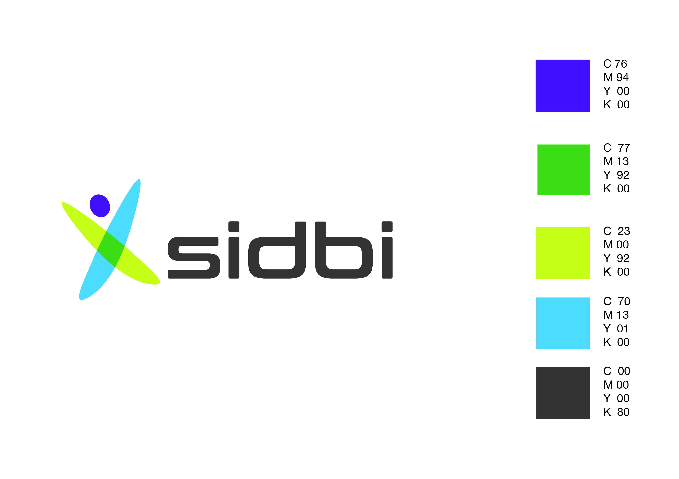

**SMALL INDUSTRIES DEVELOPMENT BANK OF INDIA**

Office No.305 & 305 A, 3rd Floor, Kakade Bizz Icon,

Pune University Road, Near E-Square, Shivajinagar,

**Pune-411 016, Tel No:(020)25530813/14**

**NOTICE OF SALE**

**Sale notice for sale of immovable properties of**

**Arrdy Engineering Innovations Private Limited**

[See proviso to rule 8 (6)]

E-Auction Sale Notice for Sale of Immovable Assets under the Securitisation and Reconstruction of Financial Assets and Enforcement of Security Interest Act, 2002 read with proviso to Rule 8 (6) of the Security Interest(Enforcement) Rules, 2002.

Notice is hereby given to the public in general and in particular to the Borrower(s) and Guarantor(s) that the below described immovable property mortgaged/charged to the Secured Creditor, the physical possession of which has been taken by the Authorised Officer of Small Industries Development Bank of India, Secured Creditor, will be sold on “As is where is”, “As is what is”, and “Whatever there is” basis on **April 22, 2019**, for recovery of `535,22,134/- (as on 10/09/2017) together with interest and other monies due to the Small Industries Development Bank of India, Secured Creditor from **Arrdy Engineering Innovations Private Limited (Borrower) and** **Shri Surya Narayana Goda, Dr. Sunanda Goda, Smt. Rukmini Goda, Ms. Jyoti Goda** and **Smt. Sunita Das (Guarantors).** The reserve price and earnest money deposit will be as under for the following properties:

|  |  |  |  |
| --- | --- | --- | --- |
| Sr. No. | Description of properties | Reserve Price  (` in lakh) | EMD  (` in lakh) |
| 1 | Flat No.209, admeasuring 625 sq. ft built up area inclusive of proportionate area in staircase and parking situated on the 2nd floor, ‘E’ Wing, Parth Complex Tirupati Residency, “Parth Co-Op Housing Society Limited, village Pen, Taluka Pen, District Raigad | **16.75** | **1.96** |
| 2 | Flat No.210, admeasuring 645 sq. ft built up area inclusive of proportionate area in staircase and parking situated on the 2nd floor, ‘E’ Wing, Parth Complex Tirupati Residency, “Parth Co-Op Housing Society Limited, village Pen, Taluka Pen, District Raigad | **17.30** | **2.02** |
| 3 | Flat No.211, admeasuring 625 sq. ft built up area inclusive of proportionate area in staircase and parking situated on the 2nd floor, ‘F’ Wing, Parth Complex Tirupati Residency, “Parth Co-Op Housing Society Limited, village Pen, Taluka Pen, District Raigad | **16.75** | **1.96** |
| 4 | Flat No.212, admeasuring 625 sq. ft built up area inclusive of proportionate area in staircase and parking situated on the 2nd floor, ‘F’ Wing, Parth Complex Tirupati Residency, “Parth Co-Op Housing Society Limited, village Pen, Taluka Pen, District Raigad | **16.75** | **1.96** |

For detailed terms and conditions of the sale, please refer to the link provided in Small Industries Development Bank of India, Secured Creditor’s website i.e. [www.sidbi.in](http://www.sidbi.in).

**Sd/-**

**Authorised Officer**

**Date:31/03/2019 Small Industries Development Bank of India**

**Place: Pune**