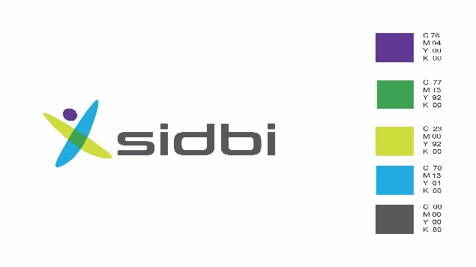

**SMALL INDUSTRIES DEVELOPMENT BANK OF INDIA**

**756 L, Overseas Towers, Anna Salai, Chennai 600002**

[**Tel:(044)66636016/66636043**](Tel:(044)66636016/66636043)

**NOTICE OF SALE**

**Sale notice for sale of immovable properties of Rajadeepan Jewellery**

[See proviso to rule 8 (6)]

E-Auction Sale Notice for Sale of Immovable Assets under the Securitisation and Reconstruction of Financial Assets and Enforcement of Security Interest Act, 2002 read with proviso to Rule 8 (6) of the Security Interest(Enforcement) Rules, 2002.

Notice is hereby given to the public in general and in particular to the Borrower(s) and Guarantor(s) that the below described immovable property mortgaged/charged to the Secured Creditor, the physical possession of which has been taken by the Authorised Officer of Small Industries Development Bank of India, Secured Creditor, will be sold on “As is where is”, “As is what is”, and “Whatever there is” basis on **May 09, 2019**, for recovery of `303,66,514/- (as on 24/10/2018) together with interest and other monies due to the Small Industries Development Bank of India, Secured Creditor from Rajadeepan Jewellery **(Borrower)** and Shri T.N.Parthiban, Shri P.Natarajan, Shri Ayyamperumal, Smt. A Subbulakshmi, Smt. N.Susila and Smt. P.Shanmugasundari **(Guarantors**). The reserve price and earnest money deposit will be as under for the following properties:

|  |  |  |  |
| --- | --- | --- | --- |
| **Sr. no.** | **Description of properties** | **Reserve price (in `)** | **EMD**  **(in `)** |
| 1 | House building bearing Door No.95, constructed in the vacant site in Tirunelveli District, Tirunelveli Taluk, Tirunelveli Registration District, Pettai Sub-Registration District, admeasuring 2950 sq. ft., ie.,    Item No.1: the western portion, admeasuring 2000 sq. ft., out of Eastern 35 cents out of 50 cents (ie., 17 cents in R.S.No.138/1B & 33 cents in R.S.No.138/2) and butted and bounded by North:East-West Road, East: Eastern portion of the building in Door No.95(Item no.2); South:Vacant site belonging to Shri. Sundaradass; West:Vacant site belonging to Shri Radhakrishnan, measuring East to West 40 Ft., on the North and the South and North to South 50 Ft., on the East and the West.  (And)  Item No.2 the Eastern portion, measuring 950 Sq.Ft., out of 50 cents (i.e. 17 cents in R.S.No.138/1B & 33 cents in R.S.No.138/2) butted and bounded by: North: East-West Road; East:Property belonging to Shri Anbarasan; South: Vacant site belonging to Shri Sundaradass; West : Western Portion of Door No.95 (Item No.1)  admeasuring East to West 19 Ft., on the North and the South and North to South 50 Ft., on the East and the West. | 83,04,000/- | 4,50,000/- |
| 2 | House building bearing Door No.48, constructed in the house site admeasuring North-Eastern 2307 sq. ft., out of 44 cents comprised in R.S.Nos.109/1B1 in Tirunelveli District, Tirunelveli Registration District, Pettai, Sub-Registration District butted and bounded by North:Vacant site belonging to Shri Seethai; East:Vacant site in S.No.109/1A; South: Vacant site belonging to Smt. Mangayarkarasi; West:North-South Road; admeasuring East to West 70 Ft., on the North and 63 ¾ feet, on the South and North to South 37 feet, on the East and 32 feet on the West. | 64,86,000/- | 3,50,000/- |
| 3 | Vacant site admeasuring western 1016.75 sq. ft., (i.e. 2.33 cents) out of Northern 4.67 cents out of 48 cents comprised in old R.S.Nos.97/B & 97/C, New T.S.No.2652/2 in Tirunelveli District, Tirunelveli Registration District, Pettai Sub-Registration District butted and bounded by: North:East-West Street; East:Eastern Portion admeasuring 2.34 Cents out of 4.67cents belonging to Shri Kaja Mohaideen; South :vacant site belonging to Shri Sekar in T.S.No.2652/2; West: Property belonging to Shri Muppidathi Konar admeasuring East to West 23 feet, on the North and 18.50 feet, on the South and North to South 49 Ft., on the East and the West T.S.W.B, Cheranmadevi Road. | 9,33,000/- | 50,000/- |
| 4 | House building bearing Door No.669 constructed in the Southern Portion of the house site bearing Plot No.1, admeasuring 1082.8121 sq. ft., out of Northern 41½ cents out of 93 cents comprised in R.S.No.162/2 in Tirunelveli District, Tirunelveli Taluk, Tirunelveli Registration District, Pettai Sub-Registration District,  **Item No.1** butted and bounded by:- North: Northern Portion of Plot No.1  **Item No.2** butted and bounded by:-East :North-South Street; South: East- West Street; West: Vacant site of Plot No.2 admeasuring East to West 33 feet on the North and 32 feet on the South and North to South 35 feet on the East and 33.75 feet on the West. | 21,50,000/- | 1,50,000/- |
| 5 | House building, bearing Door No.670, constructed in the Northern Portion of the house site, bearing Plot No.1, admeasuring 1117.1875 sq. ft., out of Northern 41½ cents out of 93 cents comprised in R.S.No.162/2 butted and bounded by:- North: Property in S.No.149; East:North South Street; South: Southern Portion of Plot No.1 (Item No.1); West: Vacant site of Plot No.2 adeasuring East to West 32 feet on the North and 31 feet on the South and North to South 35 feet on the East and 33.75 feet on the West. | 21,81,000/- | 1,50,000/- |

For detailed terms and conditions of the sale, please refer to the link provided in Small Industries Development Bank of India, Secured Creditor’s website i.e. [www.sidbi.in](http://www.sidbi.in).

**Sd/-**

**Authorised Officer**

**Date:05/04/2019 Small Industries Development Bank of India**

**Place: Chennai**