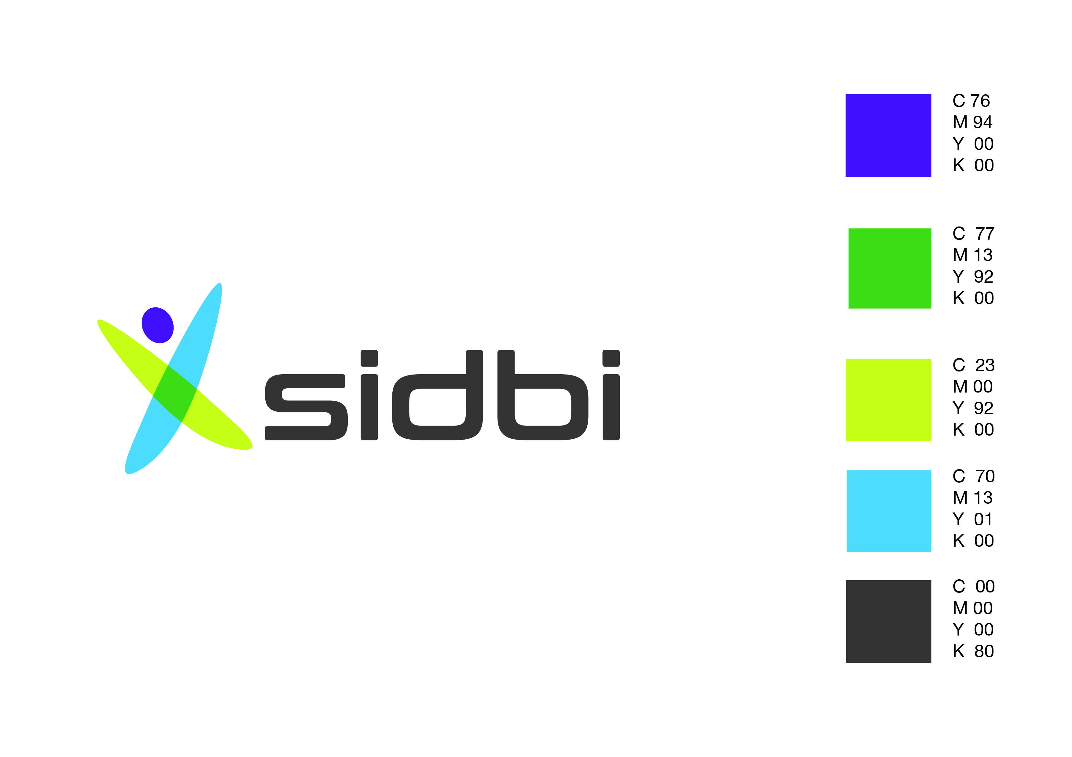

**SMALL INDUSTRIES DEVELOLPMENT BANK OF INDIA**

First Floor, Mayflower 'E' Castle, No.72, Dr.Balasundaram Road, Coimbatore -641018

**PUBLIC NOTICE FOR SALE OF ASSETS UNDER THE SECURITISATION AND RECONSTRUCTION OF FINANCIAL ASSETS AND**

**ENFORCEMENT OF SECURITY INTEREST ACT, 2002**

Whereas, the Authorized Officer of SIDBI had taken physical possession of the following properties pursuant to the notice issued under Sec 13(2) of the SARFAESI Act, 2002 in the following loan account with our Branch with a right to sell the same on **“AS IS WHERE IS BASIS AND AS IS WHAT IS BASIS”** for realization of Bank’s dues along with interest detailed hereunder and whereas consequent upon failure to repay the duesby the borrower/ mortgagor, the undersigned in exercise of power conferred under section 13(4) of the said Act, read with Rule 6, 8 & 9 and other applicable Rules of the Security Interest (Enforcement) Rules, 2002, proposes to realize the Bank’s dues by sale of the said secured assets. The sale will be done by the undersigned through e-auction platform provided at the website: [**https://sidbi.auctiontiger.net**](https://sidbi.auctiontiger.net/).

| **Sr.**  **No.** | **Name of Borrower/s and Guarantor/s** | **Name of Mortgagor/s** | **Property**  **Lot No.** | **Description of the mortgaged property** | **Earnest Money Deposit**  **` in lakh** | **Reserve price**  **` in lakh** | **Date of Demand Notice and the amount due in ` lakh** | **SIDBI Bank Account Details** |
| --- | --- | --- | --- | --- | --- | --- | --- | --- |
| 1 | M/s Rajave Textiles Pvt Ltd / Shri. S Ravindran, Shri. P Sakthivadivel, Smt R Sripriya | M/s Rajave Textiles Pvt Ltd | 1 | All the immovable properties owned by the borrower, both present and future, situated at S F No. 60/1, Kannampalayam Village, Coimbatore District, admeasuring 1.85 acres together with all the buildings and structures thereon more particularly described below.  **PART -A:**  Tiruppur Registration District [presently Coimbatore Registration District], Sulur Sub Registration District Palladam Taluk, Kannampalayam Village, S.F.No.60/1, an extent of 6.10 acres in that the property within the following boundaries.  Northof -Property belonging to Rajave Textile P Ltd:East of-North south road leading to Sulur to KannampalayamandNorthsouthPallam. :Southof -30 feet width east west cart track : Westof -Remaining land of 0.15 acres.  Within the above boundaries an extent of 30 cents Industrial land further in S.F.No.60/1 within the following boundaries.  North of:Land belonging to Rajave Mills  Eastof :Sulur to Kannampalayam road and Eastern side 0.30 acres land: Southof- 30 feet width east west of Cart Track :West. Land belonging to S.V.Chinnamma Naicker  An extent of 0.15 acres Industrial land. Thus totaling to 45 cents Industrial land with common right in the east west 30 feet road with all appurtenances thereof.  **PART – B**  Tiruppur Registration District [presently Coimbatore Registration District],Sulur Sub Registration District, Palladam Taluk, Kannampalayam village, S.F.No.60/1, an extent of 6.10 acres in that the property within the following boundaries.  North of :S.F.No.77/1 : Eastof - share of Chinnamma Naicker and RajaveTextiles Pvt. Ltd.: Southof - East West - cart track : West of - The property belonging to Rajave Textiles Pvt. Ltd  Within the above boundaries  Both sides east west .. 83 1/3 links  Both sides north south .. 300 links  An extent of 0.25 acres Industrial Land with common right in the east west 30 feet road with all appurtenances thereof.  **PART – C**  Tiruppur Registration District [presently Coimbatore Registration District],,Sulur Sub Registration District, Palladam Taluk, Kannampalayam village, S.F.No.60/1, within the following boundaries.  Northof -S.F.No.77/1: Eastof -M/s.Rajave Textiles Pvt. Ltd. Southof - East west cart track : Westof -Land belonging to Janaki  Within the above boundaries  Both sides East West ..83 1/3 links  Both sides north south.300 links  An extent of 0.25 acres Industrial land with common right in the east west 30 feet road with all appurtenances thereof.  **PART – D**  Tiruppur Registration District [presently Coimbatore Registration District],Sulur Sub Registration District Palladam Taluk, KannampalayamVillage, S.F.No.60/1, an extent of 6.10 acres in that the property within the following boundaries.  Northof S.F.No.77/1: East of North south road leading to Sulur to Kannampalayam and North south Pallam :South of Property belonging to Rajave Textiles P. Ltd.: Westof -0.25 acres land belonging to Palaniswamy  Within the above boundaries an extent of 0.90 acres Industrial land with common right in the east west 30 feet road with all appurtenances thereof. | 16.10 | 161.00 | 23rd June 2015 / ` 3,21,68,593 as on 31.05.2015plus future interest and other charges thereon. | **Name of the Beneficiary:** Small Industries Development Bank of India  **Beneficiary Account No.:** 006103000001007,  IFSC Code No.: IBKL0000381.  **Beneficiary Bank Name and Branch:**  IDBI Bank Ltd., Mayflower E Castle, Dr. Balasundaram Road, ATT Colony, Coimbatore |

|  |  |  |  |
| --- | --- | --- | --- |
| **Date and Time of Inspection­­** | **Last date of submission of EMD / Documents (including KYC)** | **Date of e-auction** | **Name & Contact Details of Authorized Officer** |
| 20.01.2018_  Between 10:00 a.m. and 14:00 p.m. | 23.01.2018  **Office Address:**  SIDBI, D No. 72, Ist Floor, Mayflower E Castle, Dr. Balasundaram Road, ATT Colony, Coimbatore | 29.01.2018  From 10:00 a.m. 12:00 to p.m.  **Webportal name** [https://sidbi.auctiontiger.net](https://sidbi.auctiontiger.net/) | Shri B.Kiran Kumar, Deputy General Manager, Mobile No.[9999115408](https://hr.sidbi.in/hrms/E_R_EMP_DTLS.asp?empcd=053707) (0422)2206013 / Email id: [bkirankr@sidbi.in](mailto:bkirankr@sidbi.in) |

**Terms and conditions:**

1. The properties are to be sold on **“AS IS WHERE ISBASIS”** and **“AS IS WHAT IS BASIS”** and it shall be the responsibility of the bidders to inspect and satisfy themselves about the assets, area, location and specification before submitting the bid.
2. To the best of knowledge and information of the Authorized Officer, there is no encumbrance on the properties other than that of SIDBI (Refer detailed terms & conditions hosted on websites). However, prior to submitting the bid, the intending bidders should make their own independent inquiries regarding the encumbrances, title of properties & claims, rights, dues affecting the properties and satisfy themselves about the same.
3. The successful bidder at the end of auction, shall pay 25% of the bid amount (inclusive of EMD already deposited) on the same day or not later than next working day after the bid is confirmed in its/ his favour. The balance amount shall be paid by the purchaser within 15 days from the date of confirmation of sale or within such extended period as may be agreed upon in writing between the purchaser and the secured creditor.
4. The successful bidder/ purchaser shall have to bear all the statutory dues, registration charges, stamp duty, taxes, etc. Authorized officer/Bank will not be responsible for any Government dues/statutory dues, etc. in respect of the properties.

**How to Bid**

1. The intending bidders shall pay the EMD to SIDBI by NEFT/ RTGS or by way of Demand Draft/ Banker’s Cheque favoring “Small Industries Development Bank of India” and payable at SIDBI’s office, as indicated above. The intending bidders will have to submit the following documents to the Authorised Officer – (1) Proof of EMD deposit, UTR no. of NEFT/ RTGS, (2) PAN card/ Form 60, (3) Latest Address Proof and also keep scanned copies of above documents ready which they will have to upload on the site [https://sidbi.auctiontiger.net](https://sidbi.auctiontiger.net/)at the time of registration, for getting login ID and password (which will be required for bidding).
2. Only those intending bidders, who are having valid User Id and Password and have confirmation of payment of EMD by way of NEFT/RTGS/ Demand Draft/ Banker’s Cheque, will be eligible to participate in the e-auction.
3. The intended bidders who have deposited the EMD and require assistance in creating Login ID & Password, uploading data, submitting bid, training on e-bidding process etc., may contact **E-Procurement Technologies Limited, A/801, Wall Street-2, Opp. Orient Club, Near Gujarat College, Ellisbridge, Ahmedabad– 380006 Support No. 079-40230816/817/818/813/814/815/820/821/822, Help Line email ID:** [**support@auctiontiger.net**](mailto:support@auctiontiger.net)Contact Persons: Mr. Vijay Shetty, Mob.No. 09619002431and Mr. Tilak Maratha, Mob. No.09067799646, Email ID: vijay.shetty@auctiontiger.net, tilak@auctiontiger.net. For any property related query Shri B.Kiran Kumar, Deputy General General Manager, Mobile No.[9999115408](https://hr.sidbi.in/hrms/E_R_EMP_DTLS.asp?empcd=053707) /0422 2206013Email id: [bkirankr@sidbi.in](mailto:bkirankr@sidbi.in) may be contacted.
4. Bidders are advised to go through the DETAILED TERMS AND CONDITIONS HOSTED ON THE BANK’S WEBSITE [www.sidbi.in](http://www.sidbi.in/) (tenders) andhttps://sidbi.auctiontiger.net

**Detailed Terms & Conditions**

1. SIDBI will be at liberty to amend / modify / delete any of the conditions as may be deemed necessary in the light of the facts and circumstances of the case. In case the offer for purchase of assets on deferred payment basis from a purchaser is accepted, SIDBI reserves its right to annul/amend the offer. Further, SIDBI also reserves its right to amend / modify / cancel the bid if it receives unsatisfactory report from the banker/s of the purchaser or for any other valid reasons.
2. The interested bidders who have submitted their EMD along with necessary documents on or before **23.01.2018 till 4:00 pm.,** shall be eligible for participating the e-bidding process. The e-Auction of above property would be conducted exactly on the scheduled Date & time as mentioned above by way of inter-se bidding amongst the bidders.The bidder shall improve their offer in multiples**` 25,000/-.** In case bid is placed in the last **5 minutes** of the closing time of the e-Auction, the closing time will automatically get extended **for 5 minutes** (subject to maximum of unlimited extensions of **5 minutes** each). The bidder who submits the highest bid amount (not below the Reserve Price) on closure of e-Auction process shall be declared as Successful Bidder and a communication to that effect will be issued which shall be subject to approval by the Authorized Officer/Secured Creditor.
3. The Earnest Money Deposit (EMD) of the successful bidder shall be retained towards part sale consideration and the EMD of unsuccessful bidders shall be refunded. The Earnest Money Deposit shall not bear any interest. The successful bidder shall have to deposit 25% of the sale price, (adjusting the EMD already paid) on the same day or not later than next working day after the bid is knocked down in its / his favour. The balance 75% of the sale price shall be paid by the purchaser within 15 days from the date of confirmation of sale or within such extended period as may be agreed upon in writing between the purchaser and the secured creditor, in any case not exceeding three months.
4. The prospective qualified bidders may avail online training on e-Auction from M/s E-Procurement Technologies Limited prior to the date of e-Auction. Neither the Authorized Officer/Bank nor M/s E-Procurement Technologies Ltd., shall be liable for any Internet Network problem and the interested bidders to ensure that they are technically well equipped for participating in the e-Auction event.
5. All bidders shall be deemed to have read and understood the terms and conditions of sale and be bound by them.
6. The purchaser shall bear the applicable stamp duties transfer charges, fee etc. and also all the statutory / non statutory dues, taxes, rates, assessment charges, fees, society charges, etc. owing to anybody related to this properties. SIDBI does not undertake any responsibility to procure any permission/ license etc. in respect of the properties/assets offered for sale or for settlement of any dues whatsoever in respect of the said properties/assets.
7. The bidders are advised to go through the detailed Terms & Conditions of e-Auction before submitting the bids and taking part in the e-Auction.
8. The publication of sale notice is subject to the force major clause.
9. The offer / bid not conforming to the terms of sale shall be rejected. Further, correspondence about any change / modification in the offer after submission of bids will not be entertained.
10. Bids once made shall not be cancelled or withdrawn. All bids made from the User ID given to bidder will be deemed to have been made by him only.
11. The sale certificate shall be issued in the same name in which the bid is submitted.
12. The intending bidders should register their name at https://sidbi.auctiontiger.net and get user ID and password free of cost. Bidders who are holding valid ID and Password provided by M/s E-Procurement Technologies Limited. for this auction after due verification of PAN are allowed to participate in online e-Auction on the above portal.
13. Bidding in the last moment should be avoided in the bidders own interest as neither Small Industries Development Bank of India nor Service Provider (M/s E-Procurement Technologies Limited.) will be responsible for any lapse / failure / (Internet / power failure etc.) in order to ward off such contingent situations bidders are requested to make all necessary arrangement / alternatives such as power supply back up etc. so that they are able to participate in the auction successfully.
14. **Refund of EMD to Unsuccessful Bidders:** Normally within 7 working days of E-auction. The bidders will not be entitled to claim any interest if the refund of EMD is delayed for any reason whatsoever.
15. The Authorised Officer reserves its right to negotiate with the highest bidders for further improvement in the offer in order to maximize the recovery of public money.
16. If the borrower / Guarantors pays in full the amount due on or before the date and time of e-auction, e-auction will be closed / cancelled and necessary communication will be sent to the bidders.
17. The e-auction will be conducted under the supervision of the Authorised officer of SIDBI and an auction agency engaged by SIDBI for the purpose.
18. Words and expression used herein above shall have the same meaning respectively assigned to them in SARFAESI Act, 2002, and rules framed there under.
19. The purchaser will not carry out any activity which is prohibited by law at the site after purchase.
20. The auction(s) would be in the nature of ‘subject to approval of SIDBI i.e. the highest bid would be finalized and kept on record until a final decision is taken on all the bids received.
21. Bank / Authorized Officer reserves the right to accept or reject any or all tenders/bids before confirmation of sale and cancel the e-auction sale without assigning any reason whatsoever. In case the E-auction schedule is cancelled before the scheduled date of sale, it will only be displayed on the notice board of SIDBI website [www.sidbi.in](http://www.sidbi.in/).
22. The successful purchaser, on payment of entire sale price and on completion of sale formalities, shall be issued a sale certificate as per format prescribed under SARFAESI Rules 2002.
23. This auction is without prejudice to SIDBI’s rights to proceed against the borrower/guarantor/hypothecator/mortgagor before Debts Recovery Tribunal, and /or as per the recovery certificate that may be obtained by SIDBI or any other recovery measure.

**STATUTORY 15 DAYS SALE NOTICE UNDER THE SARFAESI ACT, 2002**

The borrower / guarantors are hereby notified to pay the sum as mentioned above along with upto dated interest and ancillary expenses on or before the date and time of e-Auction, failing which the property will be auctioned / sold and balance dues, if any, will be recovered with interest and cost.

**Date: 12.01.2018 Sd/-**

**Place: Coimbatore Authorized Officer**

**Small Industries Development Bank of India**