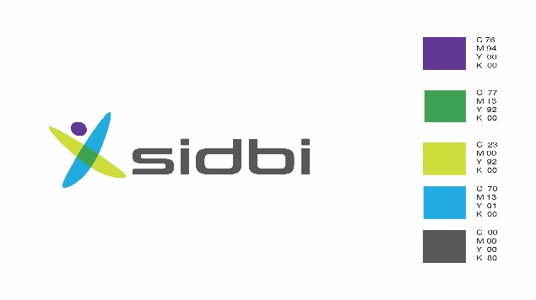

**SMALL INDUSTRIES DEVELOPMENT BANK OF INDIA**

**756 L, Overseas Towers, Anna Salai, Chennai, 600002**

**Tel:(044)66636016/66636043**

**NOTICE OF SALE**

**Sale notice for sale of movable properties of Shree Ragava Printers**

[See proviso to rule 6 (2)]

E-Auction Sale Notice for Sale of Movable Assets under the Securitisation and Reconstruction of Financial Assets and Enforcement of Security Interest Act, 2002 read with proviso to Rule 6(2) of the Security Interest (Enforcement) Rules, 2002

Notice is hereby given to the public in general and in particular to the Borrower (s) and Guarantor (s) that the below described movable property hypothecated to the Secured Creditor, the physical possession of **Shree Ragava Printers** which has been taken by the Authorised Officer of Small Industries Development Bank of India, Secured Creditor, will be sold on “As is where is”, “As is what is” and “ Whatever there is” basis on **April 24, 2019**, for recovery of `323,32,546/- (as on 17/11/2014) together with interest and other due to the Small Industries Development Bank of India, Secured Creditor from Shree Ragava Printers (Borrower) and Smt. P. Aswini, Shri N Prabhu and Shri P Chandrasekaran (Guarantor(s)). The reserve price will be `25,00,000/- and the earnest money deposit will be `1,25,000/-.

|  |
| --- |
| **Description of movable property (in dismantled condition):** Protech Plate making machine, Akiyama Single colour offset printing machine, Wellbound perfect binding machine, Wohlenburg WN1150 paper cutting machine, Automatic Folding machine, Weboffset printing machine, 3 knife trimmer / cutting machine, Mitsubhishi Daiya Single colour offset printing machine, Shinohara offset printing machine and miscellaneous items viz. electrical panel, trolley, weighing machine. |

For detailed terms and conditions of the sale, please refer to the link provided in Small Industries Development Bank of India, Secured Creditor’s website i.e. [www.sidbi.in](http://www.sidbi.in).

**Sd/-**

**Authorised Officer**

**Date:05/04/2019 Small Industries Development Bank of India**

**Place: Chennai**