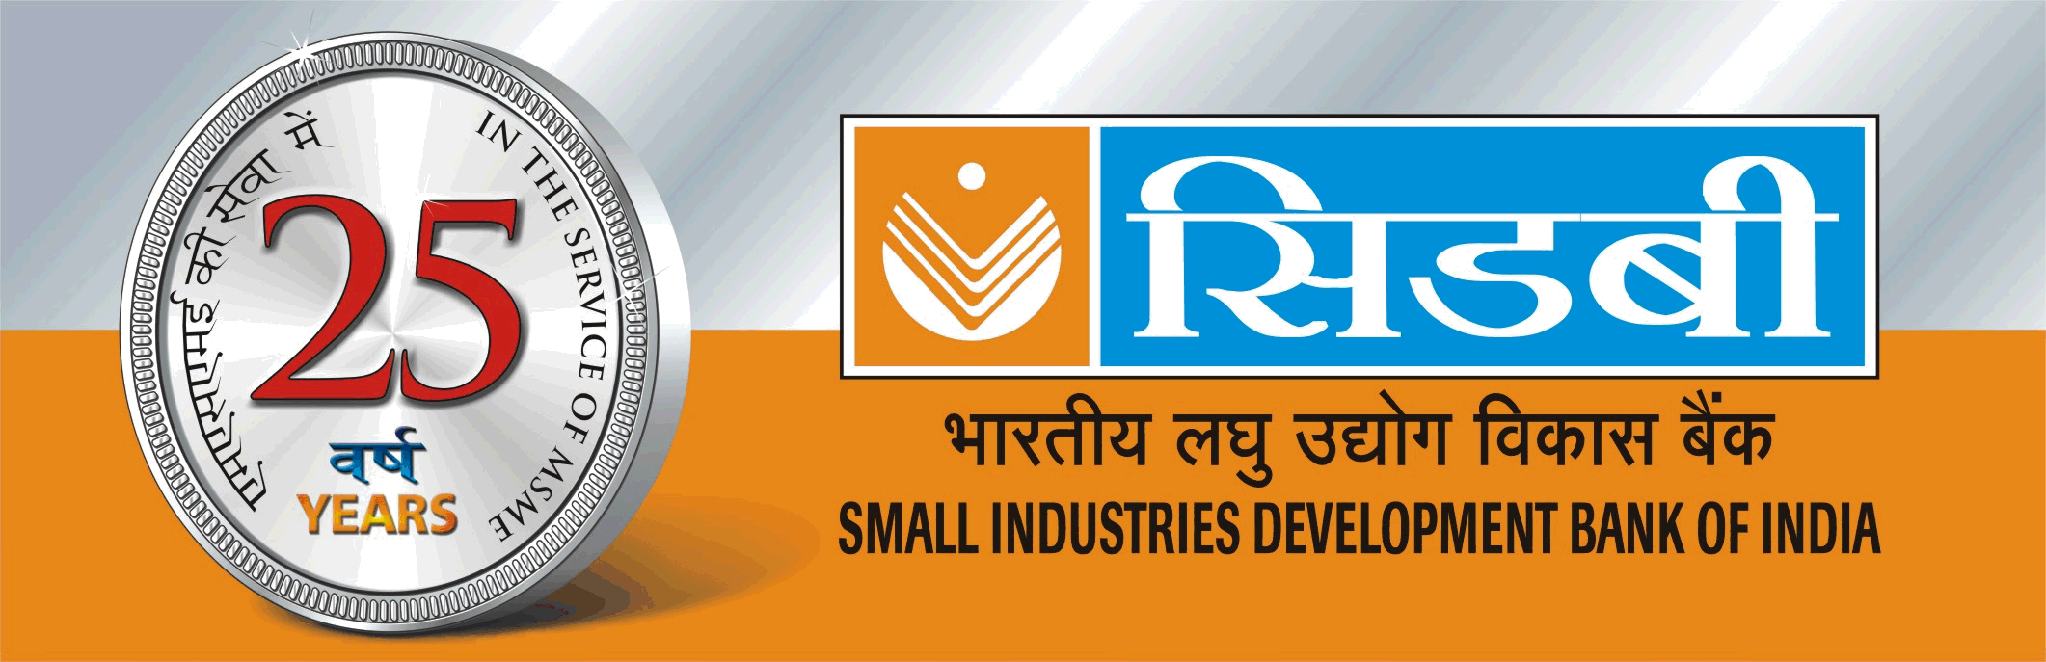
ओवर्सीस टावर्स। 756-एल, अण्णा सालै, चेन्नई – 600002
बैंक कार्यालई को किराए पर
भारतीय लघु उद्योग विकास बैंक (सिडबी) अपने निम्नलिखित परिसर को सार्वजनिक क्षेत्र के उपक्रम / बैंक, बीमा कंपनी / निजी क्षेत्र के बड़े बैंक / सरकारी संस्थान को लीज पर देना चाहता है :
“ओवर्सीस टावर्स, 756 एल, अण्णा सालै, निचला तल (टी॰ वी॰ एस के सामने), चेन्नई – 600002 स्थित कार्यालय के लिए जगह जिसका आकाट लगभग 3830 व.कु. (बिल्टअप) है. जो कि कार पार्किंग , डीजल गेनसेट, सुरक्षा व्यवस्था की सुविधाओ सहित उपलब्द है ।“
इच्छुक परत्यों बंद लिफाफे में अपने प्रस्ताव उप महाप्रबंधक, भारतीय लघु उद्योग विकास बैंक, ओवर्सीस टावर्स, 756 एल, अण्णा सालै, चेन्नई – 600002 को मार्च 30, 2015 या उससे पूर्व प्रेषित कर सकती है ।
दूरभाष सं : 044- 66636029, 66636006, 66636008
स्थान का निरीक्षण पूर्वानुमति के साथ किया जा सकता है। मध्यस्थों के साथ व्यवहार नहीं किया जाएगा । बैंक के पास बिना कोई कारण बताए किसी अथवा सभी कोटेशनों को अस्वीकार करने के अधिकार सुरक्शित रहेगा । अधिक जानकारी के लिए हमारी वैबसाइट www.sidbi.in देखें।

Registered office: SIDBI Tower, 15, Ashok Marg, Lucknow - 226001
Leasing out of Bank’s Office Premises
SIDBI desires to let out on lease to PSU / Bank / Insurance Companies/Large Pvt. Sector Banks /Govt. institutions an Office space admeasuring about 3830 sq.ft. (built up area) with DG backup, car parking and security facilities at Ground floor, Overseas Towers, 756L, Anna Salai, Chennai-600002 (opposite TVS) .

Interested parties may send their offers in a sealed envelope to Dy.General Manager, Small Industries Development Bank of India, Chennai Regional Office , Overseas Towers, 756L, Anna Salai, Chennai-600002 on or before March 30, 2015

Phone No.044- 66636029, 66636006, 66636008

Inspection of the site can be done with prior appointment. No brokers. Bank reserves the right to reject any / all quotations without assigning reasons.
For details, please visit our website www.sidbi.in

SMALL INDUSTRIES DEVELOPMENT BANK OF INDIA
Regional Office, Overseas Towers, 756L, Anna Salai, Chennai -600 002

Details of property for lease at left wing (Ground floor)
Overseas Towers, 756L, Anna Salai, Chennai -600 002

Specifications of property

1 | Details of Landlord | SMALL INDUSTRIES DEVELOPMENT BANK OF INDIA
2 | Correspondence Address: | Deputy General Manager  Small Industries Development Bank of India, Chennai Regional Office  Overseas Towers, Ground floor  756 L, Anna Salai, Opposite TVS,  Chennai – 600 002.  Tel: 044-66636029, 66636006, 66636008
3 | Location & address of lettable property | Overseas Towers, Ground floor,  756 L, Anna Salai, (Opp. TVS),  Chennai – 600 002.
4 | Proximity to important places | - Railway stations – 3 to 5 kms  - Airport – Around 15 kms
5 | Rentable built up area
5 | - Ground Floor | 3830 sq. ft. super built up area
6 | Structural details
6 | - Details of property and type of building | Multi-storied building having ground plus nine floors. Rental property available at left wing of Ground floor.
6 | - Whether Commercial? | Commercial
6 | - Structural safety? | Certified
6 | - Ready to occupy or not? | The left wing of the ground floor is available for immediate occupation. (Flooring, wiring & furnishing left for occupant’s choice).
6 | Govt. approvals and encumbrances details
6 | - Whether free from encumbrances? | Yes
6 | - Whether Corporation/ Municipal and other approvals obtained? | Yes
7 | Amenities, etc.
7 | - Car parking (open / non-covered) | Reserved open car parking available
7 | - Frontage to main road | Anna Salai
7 | - Surrounding land | Gross land area is 36,168 sq. ft. (15.07 grounds).
7 | - Power load for occupants | 35KVA
7 | - Back-up power for entire building | 2 DG sets of 380 KVA each installed for use of all occupants
7 | - Water facility | Municipal water and bore water available.
7 | - Toilet facilities | Available
7 | - Lift / Elevators | 2 lifts provided
7 | - Common facilities for the occupants | A consortium of owners takes care of all common area/facilities.
 | - Fire Fighting arrangement | Fully provided - common
 | - Security arrangements | Provided for Entrance gate of premises compound
 | - Sewerage system | Proper sewerage system is in place
 | - Provision for AC system | To be decided by the occupant
 | - Provision for telephone/IT cable | Separate trenches and ducts provided for IT/Phone/electrical cables. Electrical Panel Board and fire-fighting equipment installed in the basement.

PRICE BID
(To be submitted in Sealed Cover)

1 | Expected rentals | As per market trend on the built up area plus applicable service tax on lease rentals. The bidders should quote the rates in respect of office premises on sq. ft basis
2 | Details of terms and conditions | - Monthly rent & other payments:  Payments to be made to the landlord by way of account payee cheques / RTGS credit.  - Security deposit :  Six months’ lease rent as interest free deposit refundable at the time of vacation of premises  (c) Renewal of lease period :  The lease agreement shall be initially for a period of 3 years subject to renewal for another term of 3 years on mutual agreement in respect of office premises.  (d) Increase in rentals :  25% on the last rent paid on renewal in respect of office premises
3 | Cost of registration charges | To be borne by lessee
4 | Other charges | Electricity, DG set usage charges on actual basis. Air-condition package unit AMC on actual basis. Proportionate share of common maintenance charges, property tax, water tax, water charges, etc.
5 | Last date for receipt of offers in sealed envelope at Chennai office | March 30, 2015 by 4.00 p.m.

___________

